**Tasks/plan for the presentation/game so far:** With these tasks, everybody will have at least something to say and do, which I think is very important considering Kirill kept going on about sharing workload/ making everyone feel involved in the groups. Also, on Thursday we will present to 2 staff in a room somewhere, so no need to print loads of flyers or do that subscribe thing online. Also, the MAX time is 20 minutes for the presentation (including questions), so make sure you don’t talk too long or waffle.

Kirill sent an email with more detail criterion for the project, so this document will slightly change people’s roles in order for us to hopefully have the best chance of achieving marks in the top band.

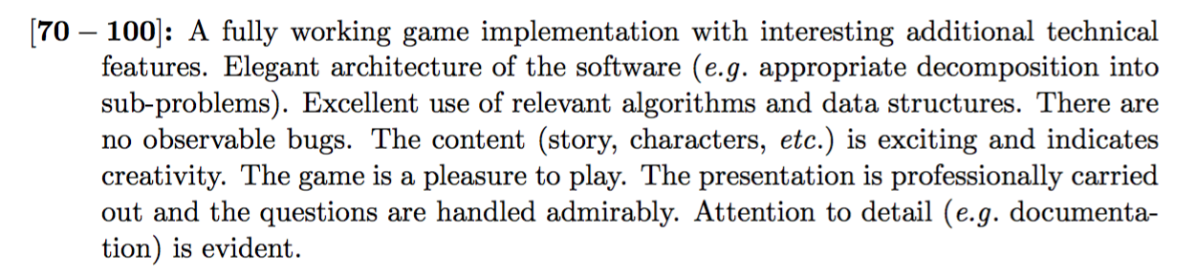Here is the top-band criteria:

Also, here is what Kirill sent which includes exactly what our presentation needs to cover:

*“Your presentation must not last longer than 20 minutes (including time for questions). It should address the details of your implementation, a justification for all of your design decisions and substantiate why the product you are offering should be purchased by RetroBazinga Ltd. Your presentation should also include a full demonstration of your game. Please remember to highlight any interesting features of your game (and aspects of*

*the content) during the presentation. If you are using any third-party libraries (such as PyGame), make sure you clearly state this in your presentation too.”*

**Here are the new roles below based on the new info sent in the email. If anyone is NOT OK with these please say, otherwise I assume you are all happy with them. New changes are in Red.**

**Bruno** - Make flyer/poster (and print it in colour) with game logo and a a few mysterious sentences enticing people to the game. Also, send some bullet points so you can talk about an idea of yours which is featured in the game.

**Apostolos** - Main coder and whom the group would fail without. Considering the amount of work done coding, no need to do anything for presentation, unless you want to or maybe you could answer tricky coding questions… apparently Kirill will play all games. If you used any third party libraries, you could mention them.

**Josh** - Presenter host, basically selling the game in an animated way by introducing game and concluding powerpoint. Making the main descriptions and room layout/map. Selling the game to RetroBazinga Ltd and why they should buy it.

**Aleksandar** - A slide or two about combat system in the game and how it benefits the game. Also, a slide with an idea of yours you liked which is implemented into the game.

**Plamen** - Talk about an idea of yours in the game. for example, the difficultly levels or other ideas which we will inevitably come up with this weekend. (not too much, but you said you don’t like presenting) Hope this is ok, if not just say so.

**Laurent** - Talk about an idea of yours in the game, sanity levels etc adds to the game experience. (not too much, but you said you don’t like presenting) Hope this is ok, if not just say so.

**Ben** - Making the presentation. I will talk about the adventure aspect, and the clues and give info on the game in general and the storyline behind it etc. As someone plays the game, I will talk about the features that are displayed such as justifying the implementation, design decisions etc. (this is why it is imperative to have a practice run on Wednesday).

So these are just points which are expanded upon the points made in the canteen, in which everybody seemed to be happy with as of then. Hope these are good starting guidelines and give the group an idea of where we are heading with the game. Obviously, they can be tweaked a bit as we know more detail about game and stuff, but these are the general areas of what people will be talking about.

We will be practicing a full run through of the presentation on **Wednesday 21st, at 11:10.** This is assuming nobody is going to computer club. But if anyone wants to obviously go and we will present at 13:10 instead.

Also, the final game (bar a few tweaks) should be ready by then, so we can also run through that and play it so we all know lots of information about it and can look more knowledgeable when answering questions etc on Thursday/Friday.

Considering we are running through the presentation on Wednesday 21st, please send me all information that you want included in the presentation by **Tuesday 20th (early evening) at latest** so I can make it for the next day.

I think that’s everything we discussed today, but I basically wanted to make a plan on paper so everyone’s on the same page. In terms of the game and ideas, we can Skype whenever or Facebook. and also do final stuff on Monday and Tuesday.

Also, Aps, sorry that you kind of have to do the coding of the game yourself, but none of us I think are at your level. Hopefully though, you can just code ideas and add in what we have all brainstormed etc so you shouldn’t have to do much in terms of the story, descriptions etc. Also, you can relax in the presentation :)

So, we have 20 minutes to present – 2 minutes for questions.

So I think a good plan of presentation time is as follows (again say something if you don’t agree).

**Approximate timings:**

Set up presentation and get game ready in Terminal/cmd.

Just before start – Bruno hands out flyers.

0-3 minutes (Intro/Selling) – Josh really selling the game.

3-8 minutes – I will go over decision implementation/main strategies and justification in game.

8-10 minutes – Aleksandar will talk about combat system and how it adds to the game.

10-16 minutes – Game demonstration.

* Here, Apostolos will run through game and I when he gets to someone’s idea, the relevant person (Aleksandar, Laurent, Plamen, Bruno) should say a few sentences about why they chose to implement this idea and how they think it adds to the game.
* When he runs through the game and no one is talking, Josh can sell the game when something cool happens, i.e. when we kill a super-human mutant.
* I will reiterate any cool aspects of the game in general and why we implemented them.

16-18 minutes – Conclusion: Josh will sell the game one more time and say after the demonstration why RetroBazinga Ltd should buy the game.

18-20 minutes – questions. (everyone go over the game and **UNDERSTAND CODE** so we are prepared - this is how we can work towards top band marks!)

As the plan shows, we definitely need to have a practice run as minutes 10-16 are somewhat non linear and we need to talk based upon what’s happening in the game. So make sure we are all there for practice run.

Also for Friday, we need to have a small summary sheet to go next to out computer saying the cool aspects of the game so someone can make this if they want to. (we can decide on Wednesday).

So that is the plan, please say something if anyone isn’t happy, but no one seems to be on Facebook, and the deadline is getting closer… so someone has to make decisions :/

Also when presenting, try to not read from a script.

Also Thursday morning before the presentation we can uploaded course work cover sheet and make github repository clear of unnecessary files etc.